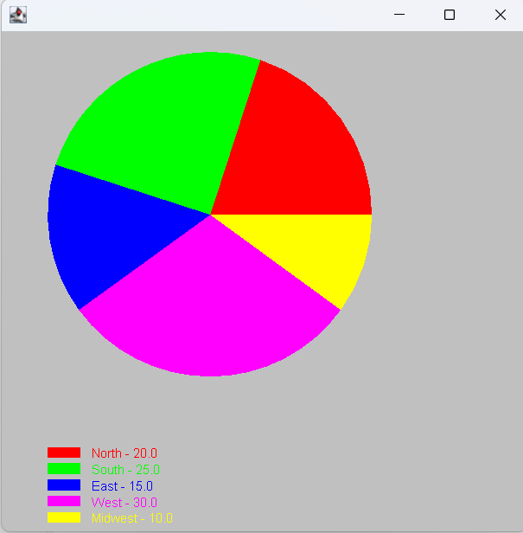

package as16;

import javax.swing.*;
import java.awt.*;

public class PieChart extends JFrame{
int x0 = 50, y0 = 50, x = 300, y = 300;
String[] regionLabels = { "North", "South", "East", "West", "Midwest" };
double[] regions;
double[] angles;
Color[] colors = {Color.RED, Color.GREEN, Color.BLUE, Color.MAGENTA, Color.YELLOW};
JPanel jpMain = new JPanel();
GridLayout gl = new GridLayout(1, 3);

public PieChart(double n, double s, double e, double w, double mw) {
int sum = 0;
regions = new double[5]; //{NORTH, SOUTH, EAST, WEST, MIDWEST}
angles = new double[5];

regions[0] = n;
regions[1] = s;
regions[2] = e;
regions[3] = w;
regions[4] = mw;

for(double d : regions) //compute a sum for percentages
sum += d;

for(int i = 0; i < 5; ++i) //compute percentages
angles[i] = 360.0 * (regions[i] / sum);
}

public void paint(Graphics g) {
x = this.getWidth();
y = this.getHeight();

g.setColor(Color.LIGHT_GRAY);
g.fillRect(0, 0, x, y);

int temp = 0; //for fillArc, to remember the last angle printed out, and start from there in the next arc
int space = 5; //spacing in between items in the legend
int pieChartX = (x * 3) / 5; //piechart X dimension
int pieChartY = (y * 3) / 5; //piechart Y dimension
int offset = (y / 2) + 125; //amount of space from the piechart to the legend
int legendRectangleX = 30; //X dimension of the rectangles in the legend
int legendRectangleY = 10; //Y dimension of the rectangles in the legend

for(int i = 0; i < 5; ++i) //draw pie chart and legend
{
g.setColor(colors[i]);
g.fillArc(x0, y0, pieChartX, pieChartY, temp, (int)(angles[i] + .5));
temp += (int)(angles[i] + .5);

g.fillRect(x0, y0 + offset + (i*10) - legendRectangleY + (space * i), legendRectangleX, legendRectangleY);
g.drawString(regionLabels[i] + " - " + regions[i], x0 + legendRectangleX + 10, y0 + offset + (i*10) + (space * i));
}

}
}

package as16;

public class TestPieChart {
public static void main(String[] args)
{
PieChart pc = new PieChart(20,25,15,30,10);
pc.setSize(500, 500);
pc.setVisible(true);
pc.paint(null);

}

}

